**Benton County Tax Number**

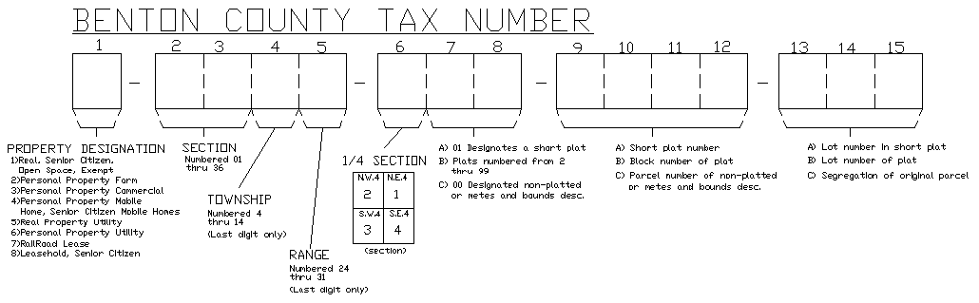

Benton County Tax/Parcel Number format is a 15 digit number. Digits 2 thru 5 describes the township/range/section of the parcel. Digit 6 describes the location of the parcel within the quarter section. Digits 7 and 8 designates what type of parcel it is. Digits 9 thru 12 describes the blocks and Tracts. Digits describe the lot numbers.

**Plats**

Parcel #: 1-2345-6XX-9012-345, the first character will be assigned based on the guidelines below.

1 = Real Parcel

4 = Mobile Home

7 = Railroad Lease

8 = Senior Citizen Lease

9 = Leased Residential Improvement (example: BSP 5828)

B = Building

Digits 2 and 3 are the Map Section: As shown on Plat (01 thru 36)

* If there are multiple sections, the new child parcel will follow its section location. (example: SP 3781)

Digit 4 the Township: As shown on Plat (4 thru 14)

Digit 5 the Range: As shown on Plat (24 thru 31)

Digit 6 describes the location of the parcel (1-2289-**2**)

* Quarter Section Number:

1 = North East Quarter Section

2 = North West Quarter Section

3 = South West Quarter Section

4 = South East Quarter Section

* Plat – The quarter section is determined by the plat map and location of the new parcel.
  + If there are multiple quarter sections, the new child parcel will follow its quarter section location.

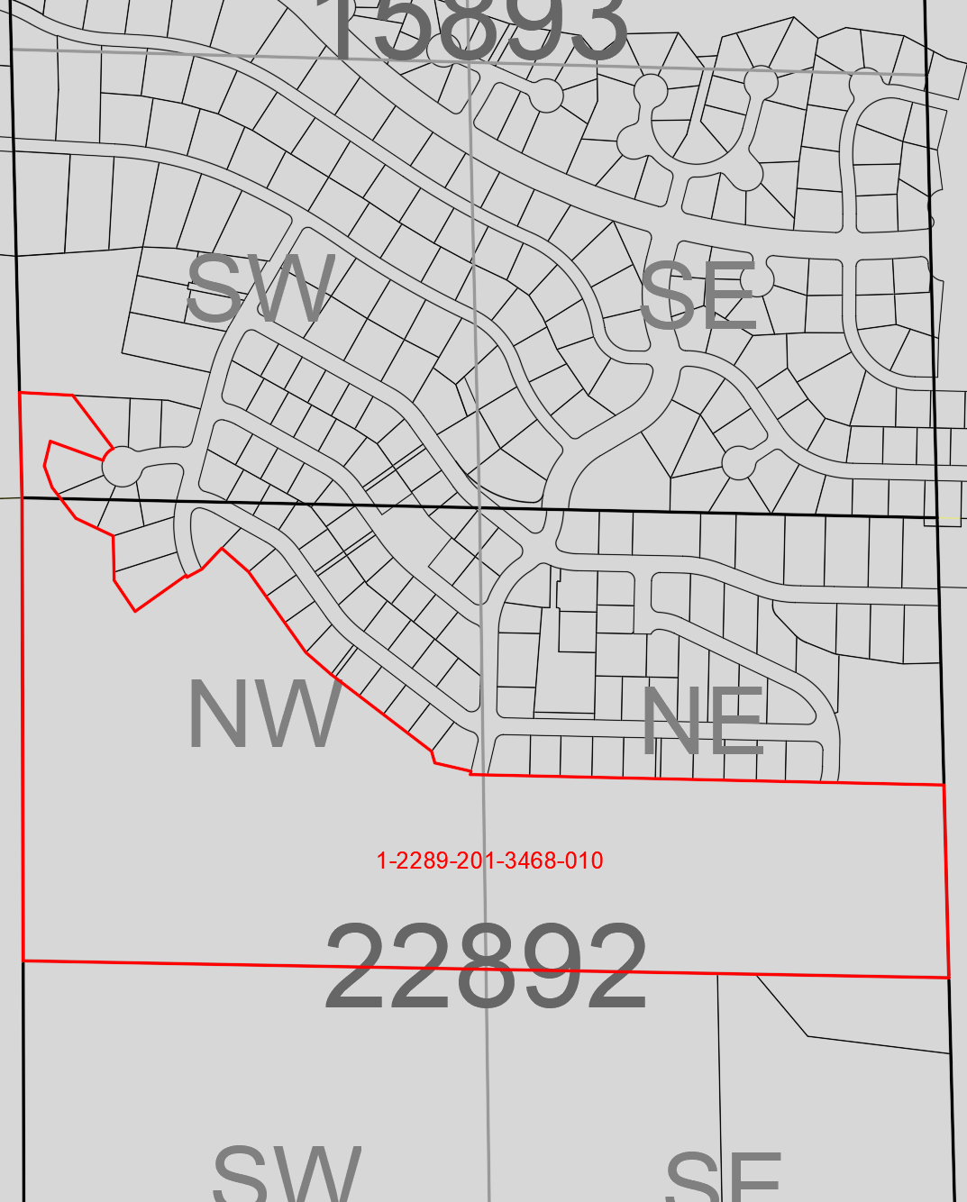

Digits 7 and 8 designations the parcel type.

* Plats – are assigned (1-2289-2**02** thru 1-2389-2**99**) in sequential order of the last subdivision number in that quarter section.
  + If the last subdivision was (1-2289-2**03**) the next subdivision will be given (1-2289-2**04**)
  + Altered/Amended Plat – digits 7 and 8 will be assigned a new number after the last subdivision in the quarter section

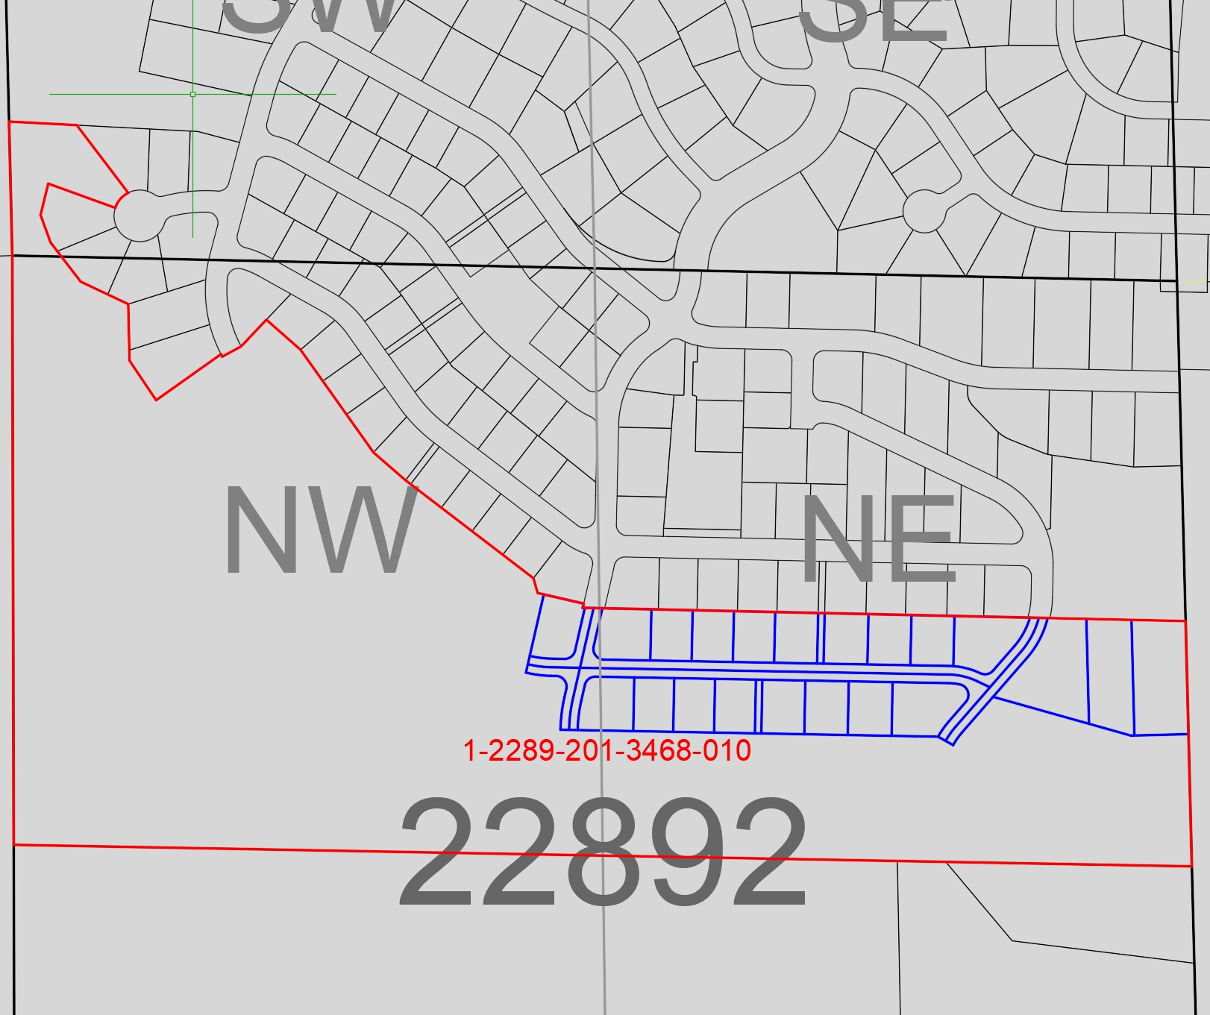

Digits 9 thru 12 Block and Tracts

* Plat – block numbers are assigned (1-2289-204-**0001** thru1-2289-204-**0099**) tracts are numbered sequentially after the last block number.
* Block 1 thru block 4 will be 1-2289-204-**0001** thru 1-2289-204-**0004**
* Tracts A thru B will be 1-2289-204-**0005** thru 1-2289-204-**0006**

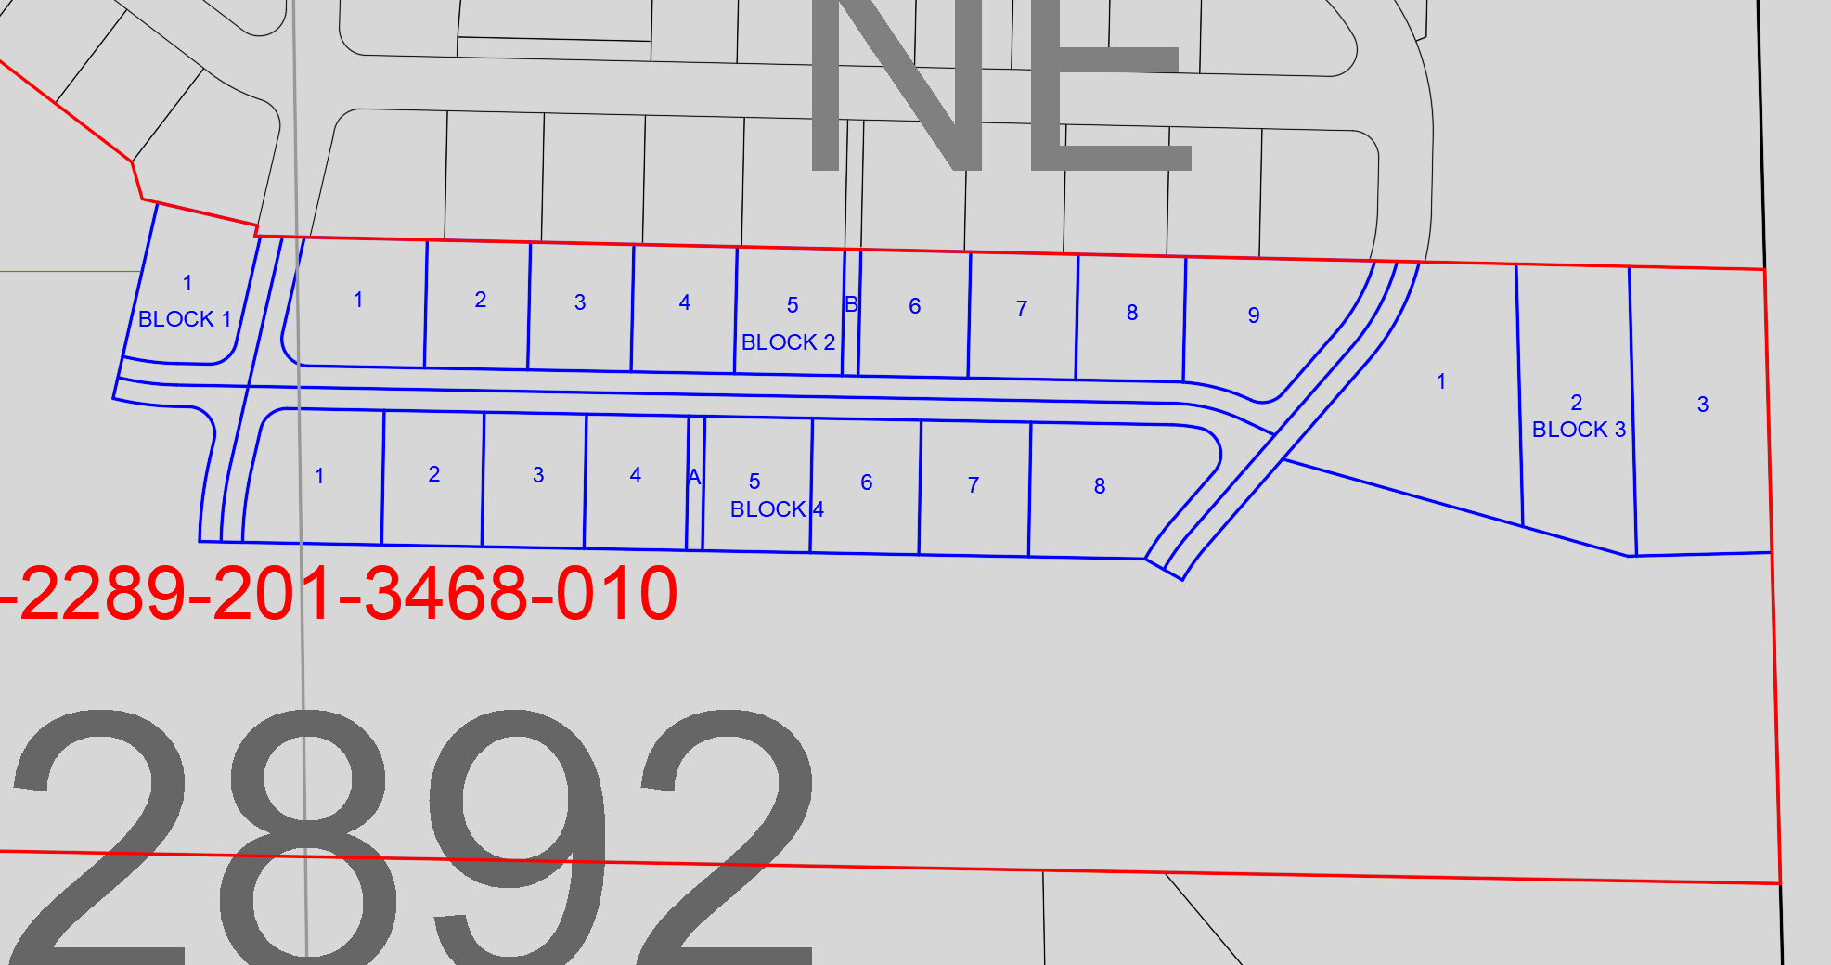

Digits 13 thru 15 Lots

* Plat – lot numbers (1-2289-204-0001-**001**) and tracts have a (1-2289-204-0001-**000**) for a lot number

**South Hill Phase 1 parcels**

Block 1                                1-2289-204-**0001**-001

Block 2                                1-2289-204-**0002**-001 thru 1-2289-204-**0002**-009

Block 3                                1-2289-204-**0003**-001 thru 1-2289-204-**0003**-003

Block 4                                1-2289-204-**0004**-001 thru 1-2289-204-**0004**-008

Tracts A thru B                 1-2289-204-**0005**-000 thru 1-2289-204-**0006**-000

**Short Plats**

Parcel #: 1-2345-6XX-9012-345, the first character will be assigned based on the guidelines below.

1 = Real Parcel

4 = Mobile Home

7 = Railroad Lease

8 = Senior Citizen Lease

9 = Leased Residential Improvement (example: BSP 5828)

B = Building

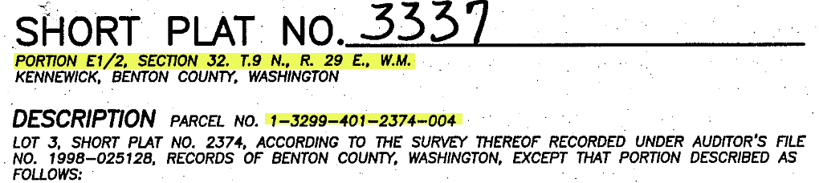

Digits 2 and 3 are the Map Section: As shown on Plat (01 thru 36)

* If there are multiple sections, the new child parcel will follow its section location. (example: SP 3781)

Digit 4 the Township: As shown on Plat (4 thru 14)

Digit 5 the Range: As shown on Plat (24 thru 31)

Digit 6 describes the location of the parcel (1-3299-**1**)

* Quarter Section Number:

1 = North East Quarter Section

2 = North West Quarter Section

3 = South West Quarter Section

4 = South East Quarter Section

* Short Plat – Quarter Section is determined by the location of the short plat
  + The parent parcel is 1-3299-401-2374-004 (Quarter Section 32994)
  + Short plat boundary is located in Quarter Section 3299**1**

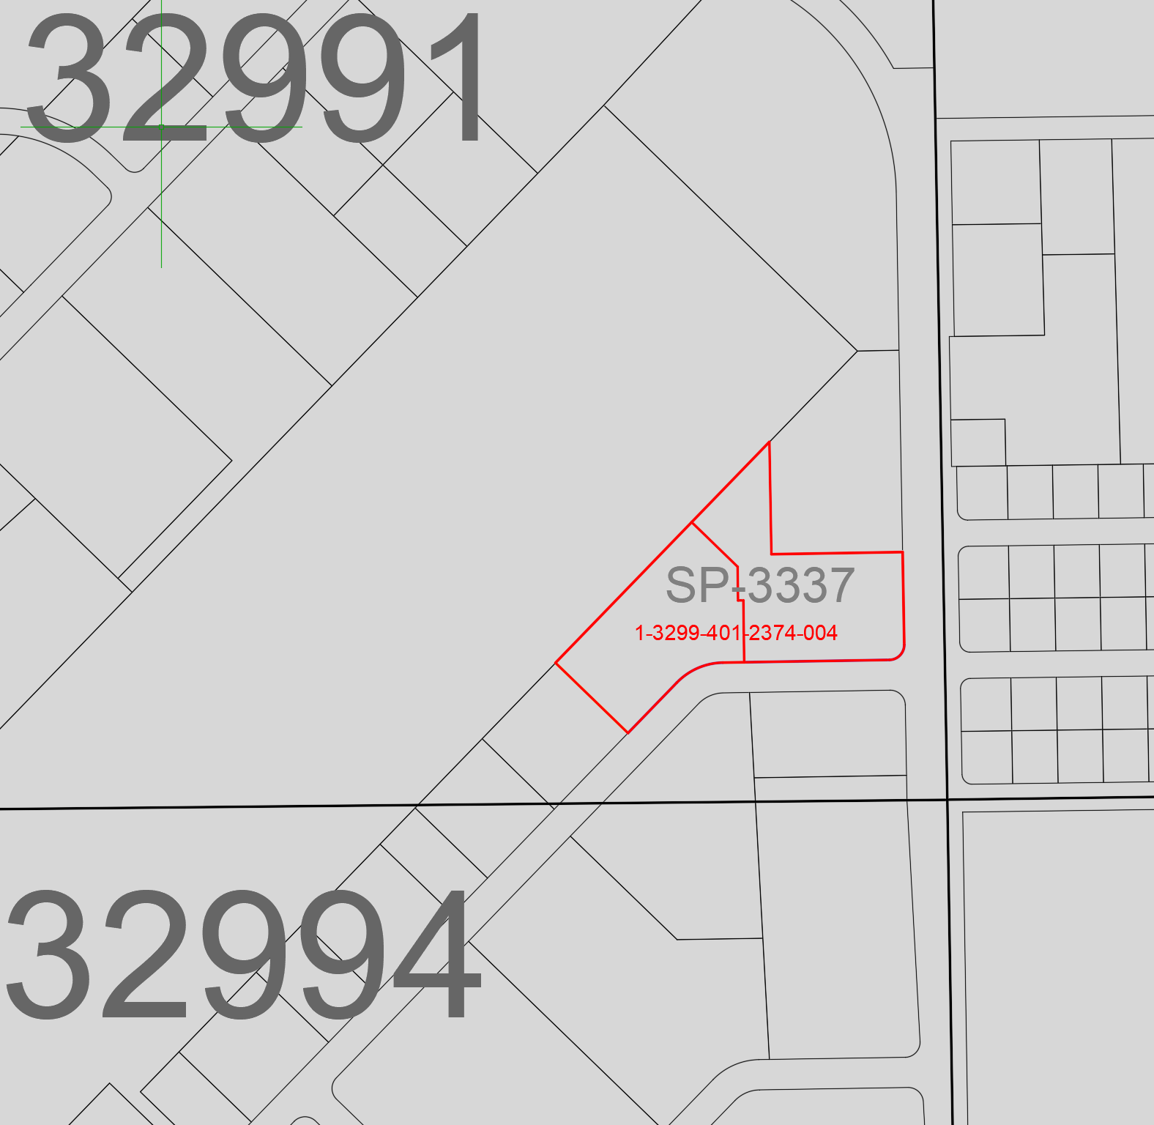

Digits 7 and 8 designations the parcel type.

* Short Plat – are assigned (1-3399-1**01**)

Digits 9 thru 12 Block

* Short Plat – will be the recorded Short Plat Number (1-3399-101-**3337**)
  + Altered/Amended Short Plat – original parcels will be retired and new parcel numbers will be assigned to the altered/amended short plat

Digits 13 thru 15 Lots and Tracts

* Short Plat – lot number (1-3399-101-3337-**001**)
* Tracts on the short plat will be given the next number after the lot number

Short Plat 3337

1-3399-101-3337-**001**

1-3399-101-3337-**002**

**Binding Site Plans**

Parcel #: 1-2345-6XX-9012-345, the first character will be assigned based on the guidelines below.

1 = Real Parcel

4 = Mobile Home

7 = Railroad Lease

8 = Senior Citizen Lease

9 = Leased Residential Improvement (example: BSP 5828)

B = Building

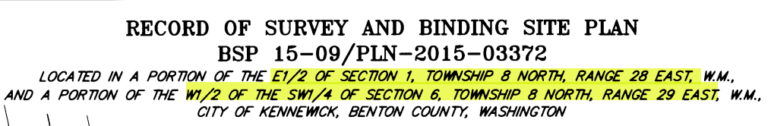

Digits 2 and 3 are the Map Section: As shown on Plat (01 thru 36)

* If there are multiple sections, the new child parcel will follow its section location. (example: SP 3781)

Digit 4 the Township: As shown on Plat (8 or 9)

Digit 5 the Range: As shown on Plat (28, 29 or 30)

Digit 6 describes the location of the parcel (1-0689-**3**)

* Quarter Section Number:

1 = North East Quarter Section

2 = North West Quarter Section

3 = South West Quarter Section

4 = South East Quarter Section

* Binding Site Plan – Quarter section is determined by the location of the binding site plan.
  + The parent parcels are 1-0188-4BP-4645-003 and 1-0689-300-0002-011:
    - If there are multiple quarter sections, the new child parcel will follow its quarter section location.

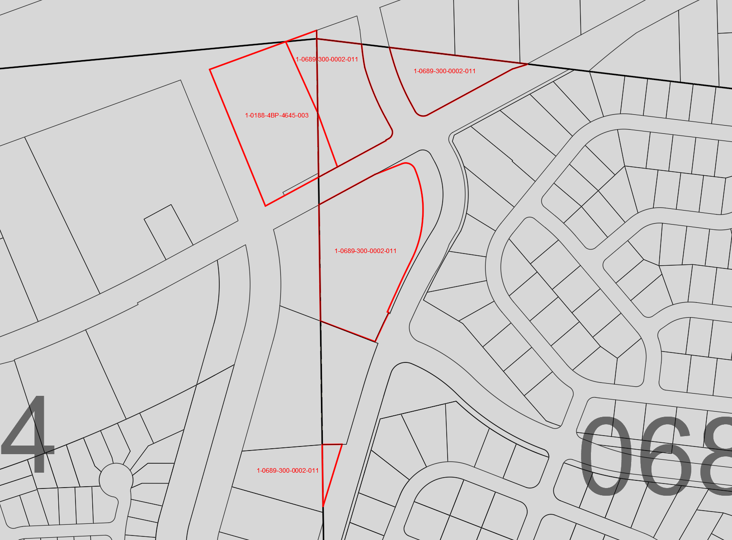

Digits 7 and 8 designations the parcel type.

* Binding Site Plan – are assigned (1-0689-3**BP**)

Digits 9 thru 12 Block and Tracts

* Binding Site Plan – will be the recorded Binding Site Plan Number (1-0689-3BP-**4740**)
  + Altered/Amended Binding Site Plan – original parcels will be retired and new parcel numbers will be assigned to the altered/amended Binding Site Plan

Digits 13 thru 15 Lots

* Binding Site Plan – lot number (1-0689-3BP-4740-**001**)

Binding Site Plan

1-0689-3BP-4740-**001** thru 1-0689-3BP-4740-**007**

**Record Surveys/Metes & Bounds**

Benton County Tax/Parcel Number format is a 15 digit number. Digits 2 thru 5 describes the township/range/section of the parcel. Digit 6 describes the location of the parcel within the quarter section. Digits 7 and 8 designates what type of parcel it is. Digits 9 thru 12 describes the blocks and Tracts. Digits describe the lot numbers.

Parcel #: 1-2345-6XX-9012-345, the first character will be assigned based on the guidelines below.

1 = Real Parcel

4 = Mobile Home

7 = Railroad Lease

8 = Senior Citizen Lease

9 = Leased Residential Improvement (example: BSP 5828)

B = Building

Digits 2 and 3 are the Map Section: As shown on Plat (01 thru 36)

Digit 4 the Township: As shown on Plat (8 or 9)

Digit 5 the Range: As shown on Plat (28, 29 or 30)

Digit 6 describes the location of the parcel (1-2389-**1**)

* Quarter Section Number:

1 = North East Quarter Section

2 = North West Quarter Section

3 = South West Quarter Section

4 = South East Quarter Section

* Record Survey/Non

Digits 7 and 8 designations the parcel type.

* Record Survey/Non-platted – are assigned (1-2389-1**00**)
* Metes and Bounds – digits 7 and 8 should match the parent parcel

Digits 9 thru 12 Block and Tracts

* Metes and Bounds – will have the same number as the parent parcel (1-2389-102-**0002** thru 1-2389-102-**0099**)

Digits 13 thru 15 Lots

* Metes and Bounds – lot number will be assigned the next number in the original parent parcel number